State Antiquity Dataset
http://www.econ.brown.edu/fac/Louis_Putterman/antiquity%20index.htm

The Dataset
The original dataset is constructed as follows. The period from 1 to 1950 C.E. is divided into 39 half centuries. Years before 1 C.E. were ignored on grounds that the experience of more than 2000 years ago would be unlikely to have much effect today.

For each period of fifty years, three questions (and allocated points) were asked as follows:

1. Is there a government above the tribal level? (1 point if yes, 0 points if no);
2. Is this government foreign or locally based? (1 point if locally based, 0.5 points if foreign [i.e., the country is a colony], 0.75 if in between [a local government with substantial foreign oversight];
3. How much of the territory of the modern country was ruled by this government? (1 point if over 50%, 0.75 points if between 25% and 50%, 0.5 points if between 10% and 25%, 0.3 points if less than 10%).

Answers were extracted from the historical accounts on each of 119 countries in the Encyclopedia Britannica.

The scores on the three questions were multiplied by one another and by 50, so that for a given fifty year period, what is today a country has a score of 50 if it was an autonomous nation, 0 if it had no government above the tribal level, 25 if the entire territory was ruled by another country, and so on.

To combine the data of the 39 periods, Bockstette, Putterman and Chanda, used a number of discount rates (statehist5) for discounting the influence of the past. The bulk of the analysis in the papers by Bockstette et. al. (the makers of the State Antiquity dataset) used statehist05, which has a discount rate of 5% (i.e., 0.05). Therefore, this is also the discount rate used in the adjusted dataset for the PharmAccess project.

For the purposes of the PharmAccess project, scores on the three questions are given for the OECD countries per year. Therefore, for the period 1801-1950 the scores are only multiplied by one another and by 1, the scores thus range between 1 and 0 in each year. Because we wanted to know what the statehist05 score was in each year after 1800, we used a yearly discount rate of 5% in the period 1801-1950.

Finally, in order to make the series easier to interpret, the sum of the discounted series was divided by the maximum possible value the series could take given the same discount rate. Thus the statehist05 value that the index could take for any given country lay between zero and one.

Adjustments
In order to make the State Antiquity dataset more historically correct regarding the period 1801-1950, some adjustments have been made.

In the original dataset, only the Czech Republic has been given a lower score (0,5 on the second question) because of the German occupation during the Second World War. In the adjusted dataset, all occupied countries received this score (0.5) during the occupation.

Australia has been given a score of 0.75 (1,0.75,1) for the period 1801-1850 and a score of 1 (1,1,1) for the period between 1851 and 1950 in the original dataset. However, as Australia only gained independence in 1901, a score of 0.75 has been given to the entire period between 1801 and 1900 and a score of 1 has been given to the period 1901-1950.

Italy has been given a score of 0.5625 for the period between 1801 and 1850 and a score of 1 for the remaining period, in the original dataset. However, as Italy was only unified in 1861 a score of 0.5625 is given for the period 1850-1861 as well.

Korea has a score of 1 up to 1900 in the original dataset. Because the Japanese occupation endured from 1910 to 1945, a score of 1 has been given to the first decade of the twentieth century as well.

Norway: because the union with Denmark endured up to 1814 a score of 0.5 is given up to 1814. Than, because of the union with Sweden from 1815-1905, Norway received a score of 0,75 for this period. Finally, Norway is given a score of 1 from 1906 onwards. In the original database Norway was given a score 0.75 for the period 1801-1900 and from 1901 to 1950 score 1.

Graphs
Because all countries receive positive values for each year of existence all countries’ values have an upward trend. Only Korea, which has the highest statehist value of the countries in the database, because of its long history under the control of consolidated domestic powers (i.e. the Koryo kingdom, the Ch'oe military regime, and the Choson dynasty, between 936 and 1910), has a declining value in the last decades because of the long Japanese occupation.

Looking at the graph of America, Asia and Oceania, Britain’s former colonies, Australia, Canada, New Zealand and the United States, have the lowest values in the database, because of the late initial settlement (especially in Australia and New Zealand) by large groups of white settlers and because of the British rule. Japan, Korea and Turkey have the highest values in the database because they were unified and ruled domestically for long periods in history. Mexico is in the middle because of the early existence of the Maya empire and the long period of Spanish rule. Mexico has a rising value after 1821 as it gained independence.

Looking at the graph of Europe, al countries have higher values than the former British colonies, because of the earlier existence of settlements and some sort of rule, whether or not locally based. France, Austria, Switzerland and the United Kingdom naturally have high values as they were unified and ruled domestically since the Middle Ages.

These countries are followed closely by Germany, Denmark, the Netherlands, Spain and Belgium. Germany consisted of a large number of small states during the Middle Ages and Early Modern period was unified only in 1871. Denmark gained and retained unified home rule in the thirteenth century. Spain was unified and domestically ruled after the completion of the Reconquista (1492). The Netherlands and Belgium have long been under foreign rule with some level of local autonomy. The Netherlands has higher values because it gained independence and began to assume its current governmental structure after the Union of Utrecht (1579), while Belgium gained complete independence only in 1830.

Because control over Italy was divided between the domestic city-states as well as the French and the Spanish during the Late Middle Ages and Early Modern period, Italy has somewhat lower values than the former countries. The Czech Republic, Poland, Hungary, Sweden, Norway, Greece and Ireland are all in the middle of the graph because of the long periods of foreign rule.

Finally, Iceland, Slovakia and Finland have received the lowest values in Europe. Iceland and Finland had been settled only from the thirteenth century onwards. Iceland was subject to Norway and later Denmark, even though it had some local autonomy, and Finland was subject to Sweden and later Russia and gained independence only in 1917. Slovakia was settled earlier, but has been under foreign rule during the entire period under consideration.

Literature
In a number of articles a significant correlation between the statehist5 value and other indicators of economic development is demonstrated. In the article “States and markets: The Advantage of an Early Start”, Valerie Bockstette, Areendam Chanda and Louis Putterman, show that the statehist5 variable is significantly correlated with measures of political stability and institutional quality, with income per capita, and with the rate of economic growth between 1960 and 1995. The findings of their paper suggest that an early territory-wide polity and experience with large-scale administration, produces both a more effective government and is a contributing factor in economic growth. Furthermore, they argue that the statehist variable can be used to explain the cross-country differences in worker productivity, because the statehist value helps to predict the ‘social infrastructure‘ variable that Hall and Jones (1999) have introduced to explain differences in capital stock, total factor productivity and output per worker.

In the article “Early Starts, Reversals and Catchup in the Process of Economic Development”, Chanda and Putterman argue that those early states like China, India, Italy and Greece have been experiencing more rapid economic growth in recent decades than have latecomers to statehood such as New Guinea, the Congo and Uruquay (not included in the dataset for the PharmAccess project). Their argument is reinforced by demonstrating the positive correlation between GDP per capita and the stathist value. This correlation is shown in figure 1 and 2.

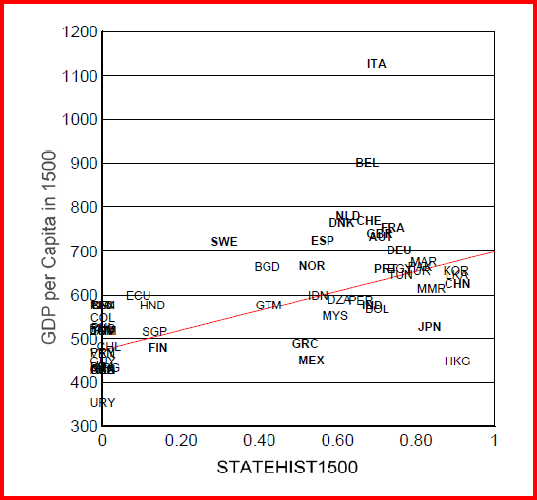
Figure 1: Correlation between GDP per capita in 1500 and Statehist variable

In a third article, “Social Capability, History and the Economies of Communist and Postcommunist States,” Peter Iliev and Louis Putterman discuss how differences in early state formation (the statehist variable), among geographical and social factors, have affected the capabilities of countries for operating planned economies and the differences in facilitating the transition from a planned to a market economy. They find that the statehist variable is positively correlated with the performance of planned economies, as well as with transition growth rates, especially with regard of the Eurasian socialist core countries.

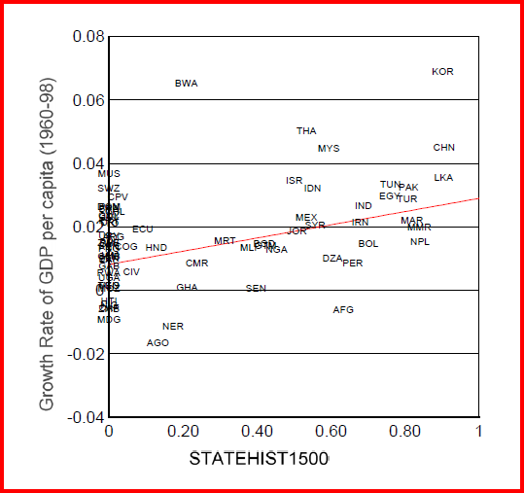
Figure 2: Correlation between GDP per capita growth rate (1960-98) and Statehist variable

Valerie Bockstette, Areendam Chanda and Louis Putterman, “States and markets: The Advantage of an Early Start”, Journal of Economic Growth 7 (2002) 347-69.
Ibid., 362.
Ibid., 365.
R.E. Hall, and C.I. Jones, “Why Do Some Countries Produce So Much More Output per Worker Than Others?”,The Quarterly Journal of Economics 114 (1999) 83-116.
Areendam Chanda and Louis Putterman, “Early Starts, Reversals and Cathcup in The Process of Economic Development”, Brown University, Department of Economics, Working Paper 4 (2004) 1-43.
Ibid, 42-43.
Graph taken from ibid., 42.
Peter Iliev and Louis Putterman, “Social Capability, History and the Economies of Communist and Post-Communist States”, Studies in Comparative International Development 42 (2007) 36-66, there 54.
Graph taken from ibid, 43.

