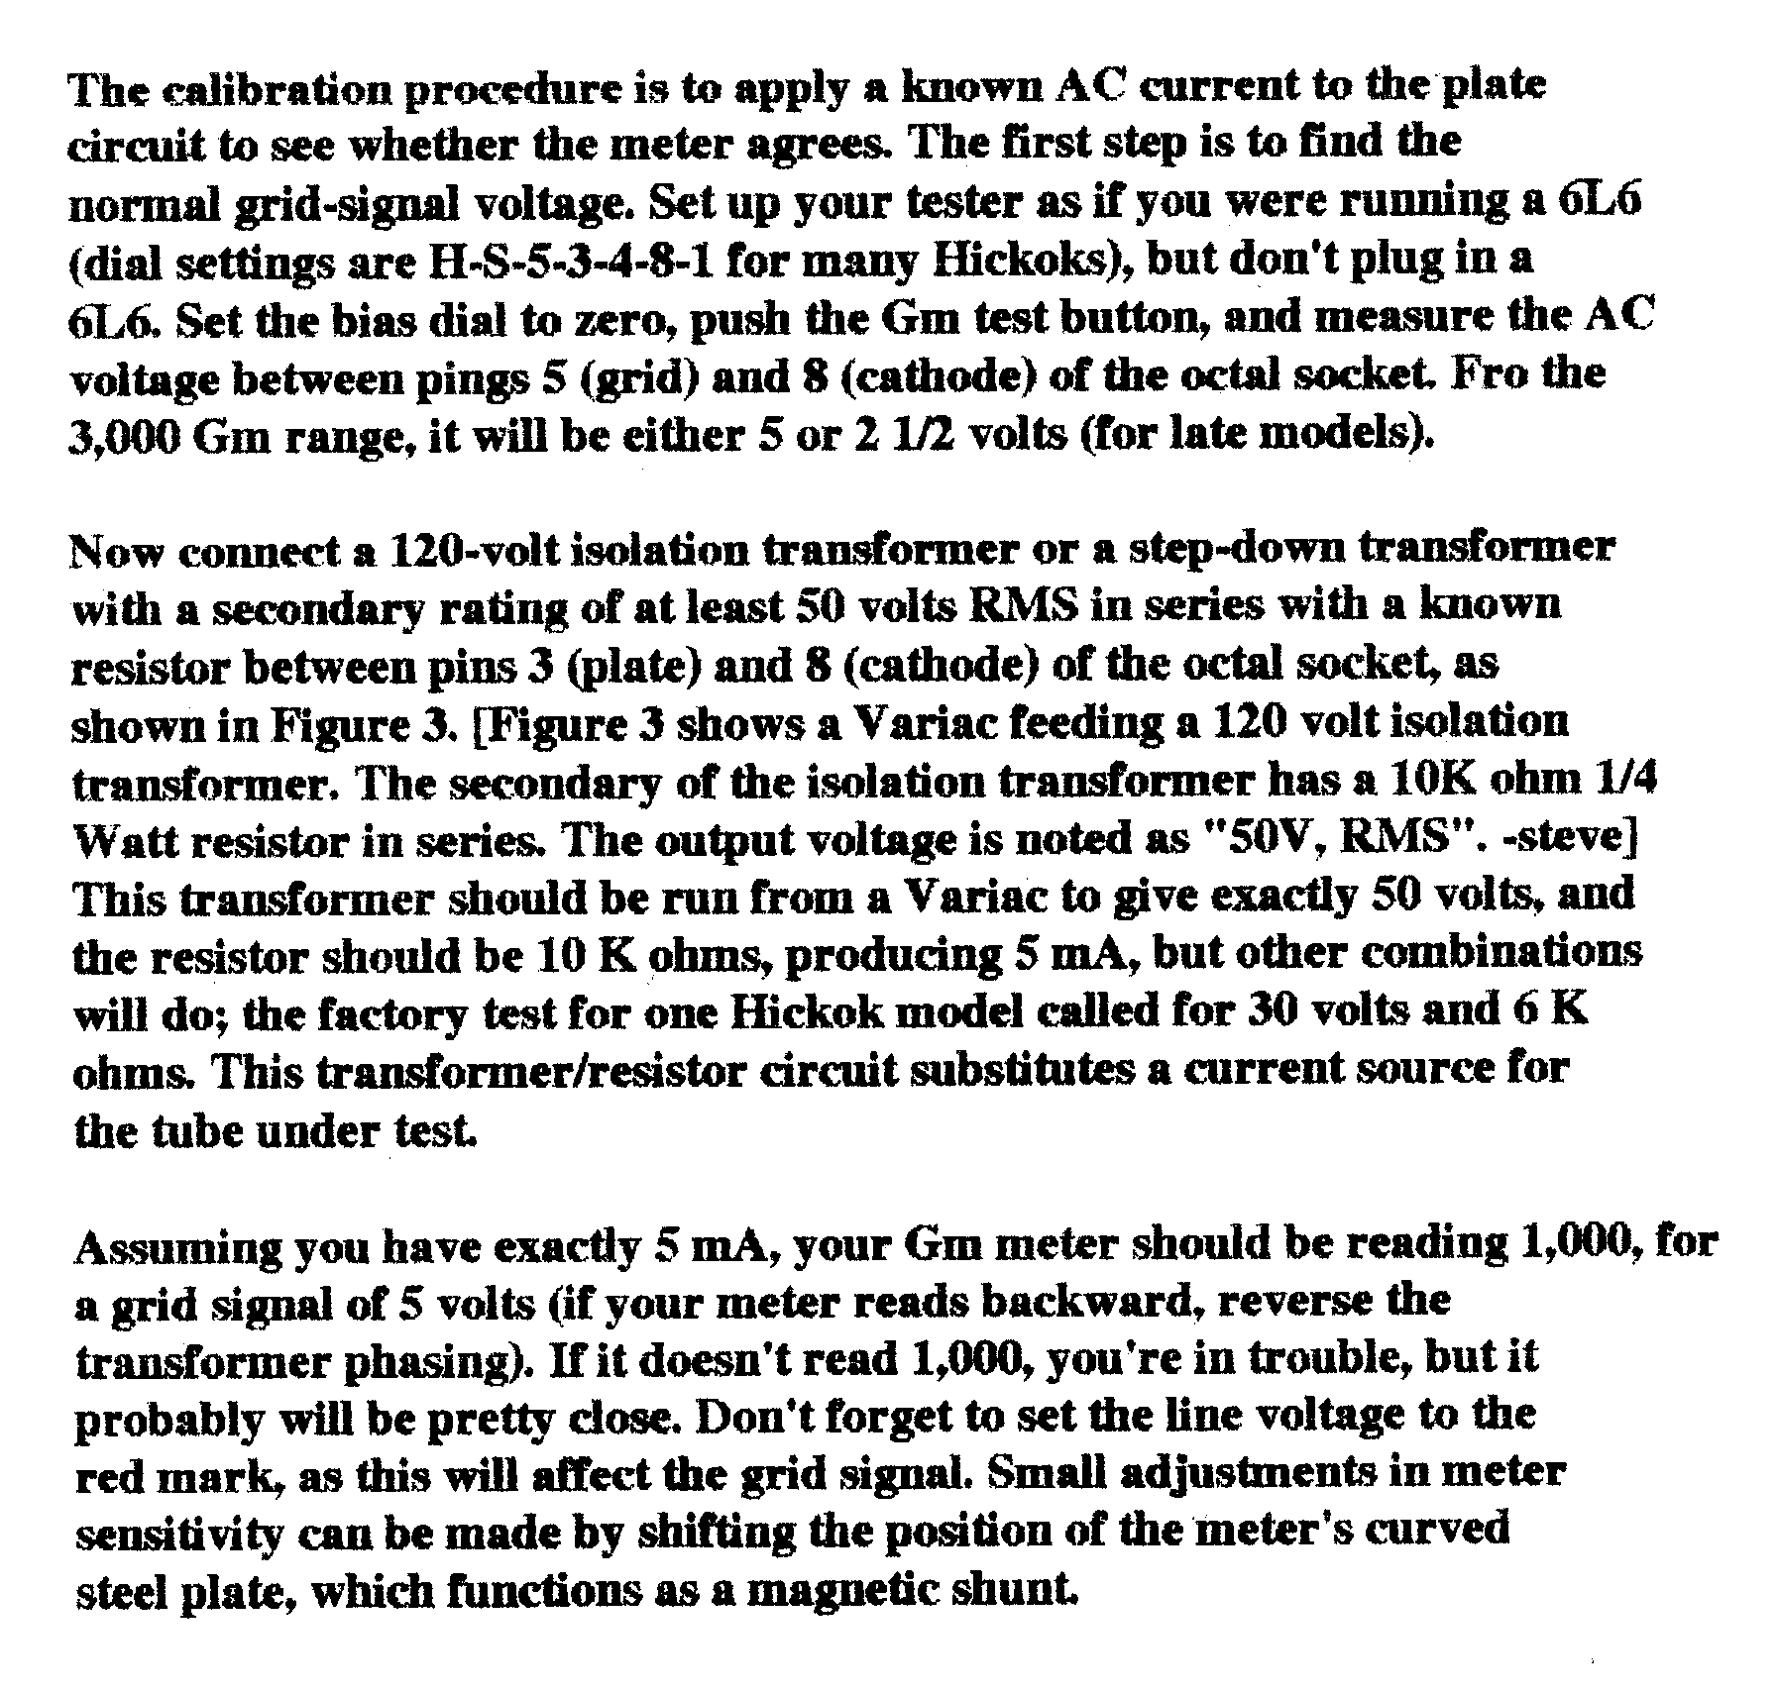
539C CALIBRATION PROCEDURE

